Contents
1 Project 3
1.1 Project 3
1.2 Description 3
1.3 Revision History 3
2 Overview 4
2.1 Purpose 4
2.2 Scope 4
2.3 Requirements 4
2.3.1 Estimates 4
2.3.2 Traceability Matrix 4
3 System Architecture 5
3.1 Hardware Requirements: 5
4 Data Design 6
4.1 Data Dictionary 6
4.2 Persistent/Static Data 6
4.2.1 Dataset 6
4.2.2 Static Data 6
4.2.3 Persisted data 6
4.3 External Interface Data 7
4.3.1 RabitMQ : 7
4.4 Transformation of Data 7
4.4.1 ApplicationUpdate : 7
5 Software Domain Design 8
5.1 Software Application Domain Chart 8
5.2 Software Application Domain 9
5.2.1 Sub Component 9
5.2.2 Class Diagram 10
5.2.3 Use Cases 10
5.2.4 Deployment Diagram 12
6 Other Interfaces 12
6.1 Interface X 12
7 Outstanding Issues 13
8 Non Functional Requirement 13
9 References 13
10 Glossary 13

Project

Project
Digital onboarding platform, which allows NI to onboard merchants digitally. 3ds2.0 Mastercard Identity Check Onboarding for 3-DSecure Acquirers and Service Providers

Description
The purpose of this document is designed to help 3-D Secure Service Providers, Acquirers through the onboarding processes of program registration, testing, and production readiness.

Revision History
Date | Comment | Author
21 Nov 2002 | Initial Draft | Sudesh Mane
23 Nov 2002 | Initial Draft | Sudesh Mane

Overview

Purpose

Mastercard Identity Check is a global authentication program that utilizes the Mastercard authentication network in conjunction with the EMV 3-D Secure® protocol. It is designed to help provide additional security for digital transactions and to help facilitate higher approval rates, by improving the authentication experience for merchants, issuers, and card holders. The purpose of this guide is to assist 3-D Secure Service Providers, Acquirers, and Merchants through the onboarding processes of program registration, testing, and production readiness. For more specifics regarding the Mastercard Identity Check program, please refer to Mastercard Identity Check Program Guide available on Mastercard Connect publication library. To help determine the steps required to onboard with Mastercard Identity Check, it will be important to determine your appropriate Identity Check customer type and associated scenario before Onboarding Guide.

Scope
Acquirer—The Mastercard principal customer that provides the authorization and/or clearing functions for their merchants using Mastercard Identity Check and EMV 3DS.
DOB - A 3DS requester using authentication services from a 3DS server. The 3DS requester may use a 3DS SDK.

Requirements
Break down the requirements to provide a ballpark estimate.

Traceability Matrix
Cross reference this document with your requirements document and link where you satisfy each requirement
SRS Requirement | SDD Module
Req 1 | [NASSC-2221] MasterCard 3Ds 2.0 - Jira (atlassian.net)

System Architecture
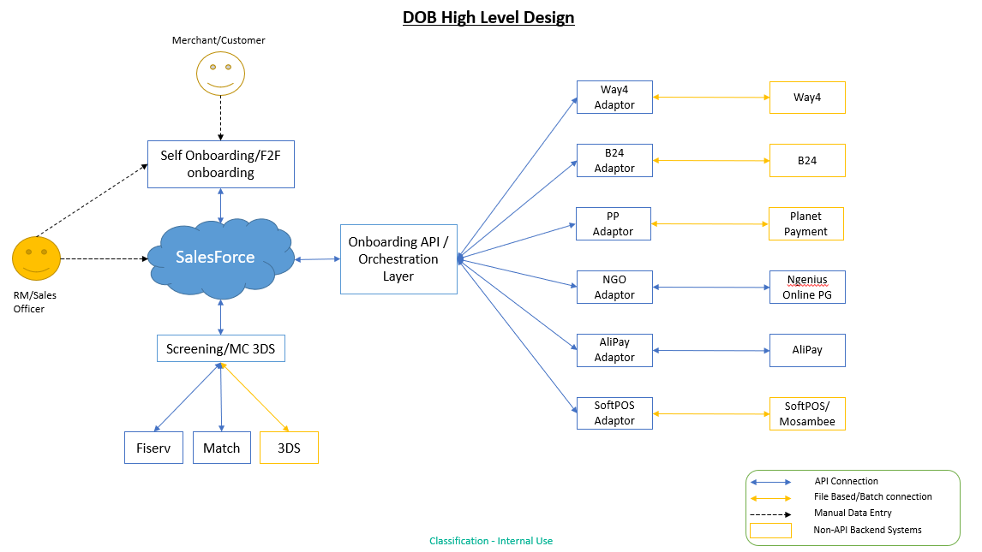

Hardware Requirements:
Standard Server config | ELK Server (if no shared service available)
RHEL 7 (or latest available) | RHEL 7 (or latest available)
8 core cpu | 8 core cpu
80GB storage | 1000GB storage
32GB memory | 32GB memory

  - Software Requirements:
Component | Infrastructure | Licensing
Java 8 | 2 RHEL Linux server | Commercial license, Included with server provisioning
RabbitMQ Cluster | same servers | We use free open-source version, commercial version is available with a subscription fee for support.
Selenium | same servers | Free
Ansible | 1 server | Free, commercial support available
ELK | 3 servers | Free, commercial subscription available
MongoDB | 2 servers | Free, commercial support available

Data Design
Describe the data contained in databases and other shared structures between domains or within the scope of the overall project architecture

Data Dictionary
Table - 3ds2.0_acquirerConfig
Field | Notes | Type
orgId | Organization Id | VARCHAR
Acquirer | NI | VARCHAR
acquirerBin | 230516 | NUMBER
acquirerCompanyId | Acquirer Company Id | NUMBER
acquirerPrimaryIca | ICA associated with the Acquirer Bin, provided by Master Card | NUMBER
companyName | network international | VARCHAR

Persistent/Static Data
Describe/illustrate the logical data model or entity relationship diagrams for the persistent data (or static data if static)

Dataset
Describe persisted object/dataset and its relationships to other entities/datasets
- Collection - 3ds2.0_acquirerConfig
- orgId "MCXX"
- complexTariffStructure False
- Acquirer "NI"
- acquirerBin "XXXXX"
- acquirerCompanyId "XXXX"
- acquirerPrimaryIca "XXXX"
- companyName "network international"

Static Data
- processor: MPGS
    - identityCheckExpress: N

Persisted data
- Collection - 3ds2.0_request
- Payload
- Request
- Response
- Task
- TaskHistory

External Interface Data
Any external interfaces’ data goes here (this is for the data, section 8 is for the interface itself)

RabitMQ :
- Configuration
- Name :- 3ds2.0
- routingKeys :- routing.backend.3ds2.0

Transformation of Data
Describe any data transformation that goes on between design elements

ApplicationUpdate :
- Configuration
- BackendSystem :- _3ds2
- ApplicationId :- Id of payload
- AdditionalData
  - transactionID - Unique ID of the transaction ID is used in getMerchants call to see the status of the merchant enrollment.
  - messageType - Type of the message
  - totalRecords -Total number of records processed

Software Domain Design

Software Application Domain Chart

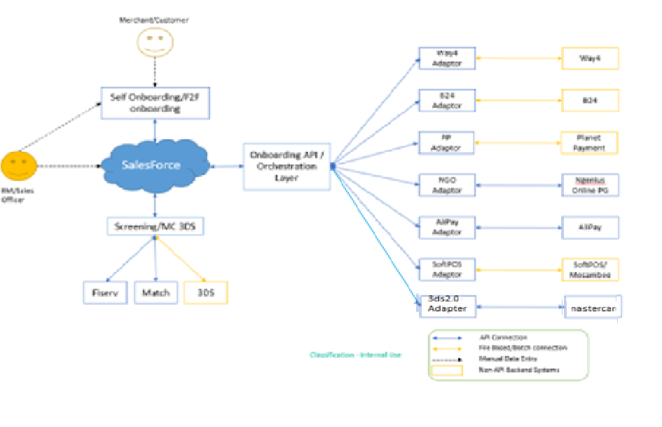

Software Application Domain

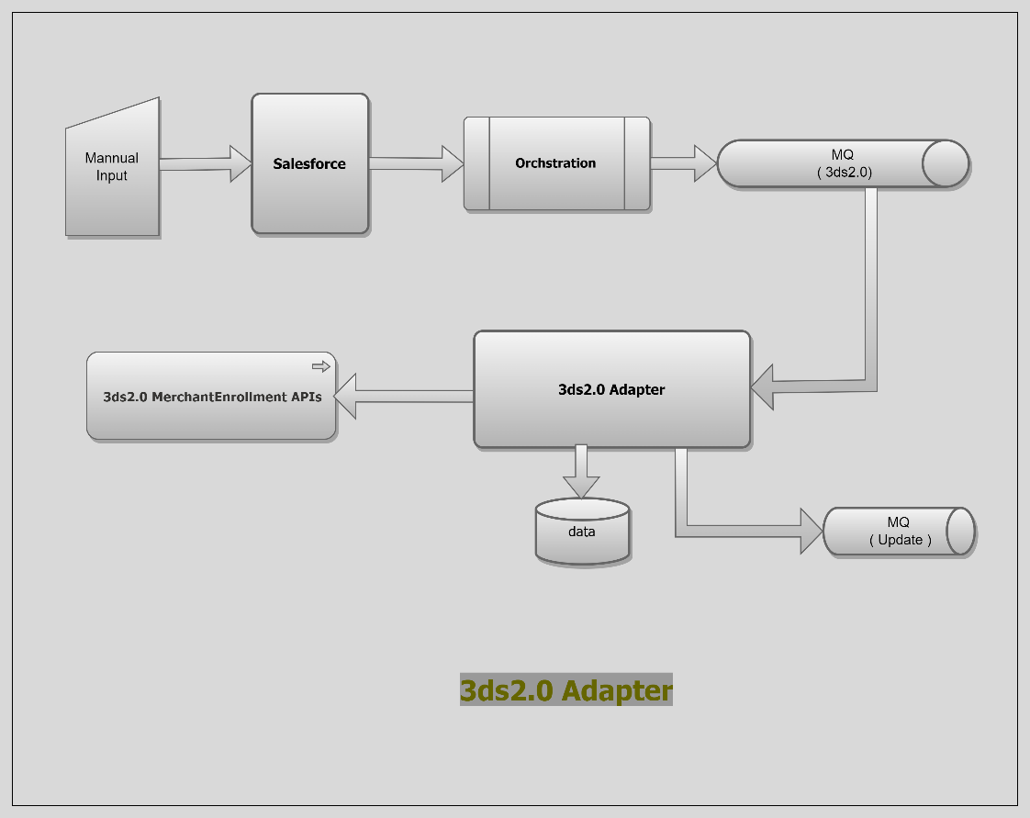

Sub Component
- Salesforce - User will provide inputs merchant id, merchant name, request type to call merchant enrollment services

- Orchestration - will redirect payload to RabbitMQ

- RabbitMQ - will serve payload to 3ds2.0 adapter which is continuously listen to RabbitMQ

- Adapter - will consume payload. Adapter will validate payload whether payload data is in proper format or not. Payload which is valid, will persist in database and call to Merchant Enrollment Api. Transaction Id will pass to RabbitMQ in case of merchant-creation and task history will store in database

- Merchant Enrollment : API Enrollment(create) API is used to enroll or delete merchants into the Mastercard Identity Check Program. The Acquirer or Service Provider must provide the required merchant details to successfully complete this task. A transaction ID is sent back in the response that can be used to get the status of the enrollment.

Class Diagram

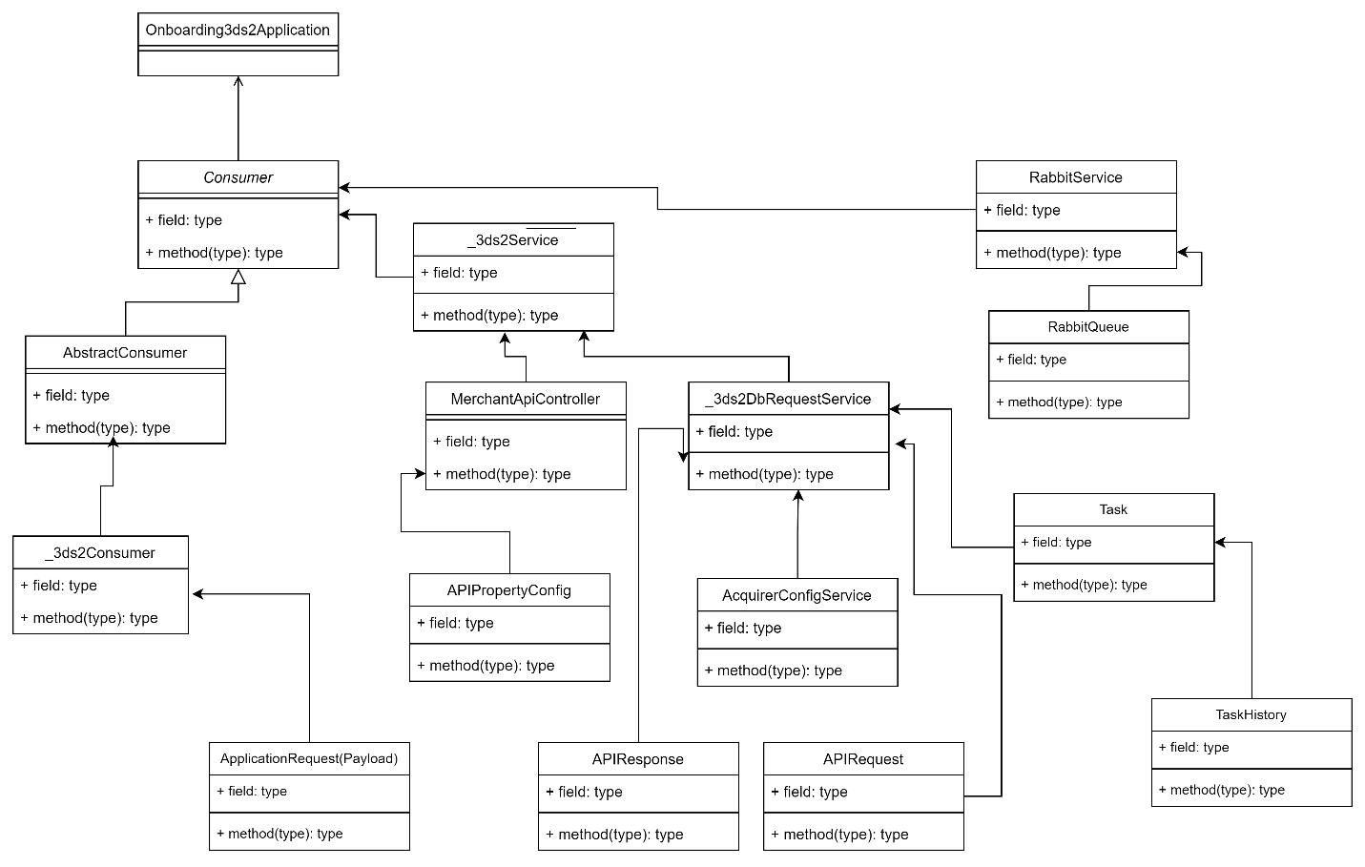

Use Cases

Adding a merchant
A Service Provider has integrated a merchant onto EMV 3DS and wants to start using Mastercard Identity Check. Before they can send authentication transactions to the Mastercard Directory Server the merchant needs to be enrolled into the Identity Check program. This can be facilitated through the Merchant Enrollment API using the ADD action in the request.
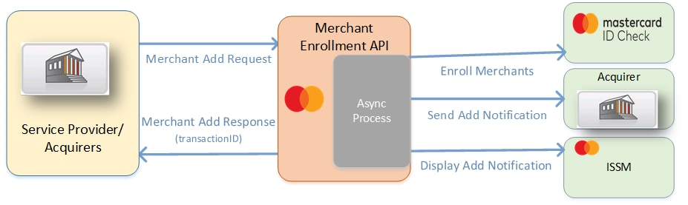
Authentication
API to add or delete the merchants into the DS Platform. All request and response payloads are sent in the JSON (JavaScript Object Notation) data-interchange format. Each endpoint in the API specifies the HTTP Method used to access it.
Mastercard uses OAuth 1.0a for authenticating the API clients. This requires every request that you send to Mastercard to be signed with an RSA private key. A private-public RSA key pair must be generated consisting of:
- A private key for the OAuth signature for API requests.
- It is recommended to keep the private key in a password-protected or hardware keystore.
- A public key is shared with Mastercard during the project setup process through either a certificate signing request (CSR) or the API Key Generator.
- Mastercard will use the public key to verify the OAuth signature that is provided on every API call.

The Merchant Enrollment(query) API provides the status of the merchants enrolled or deleted using the transaction ID from the Enrollment(create) API call.
Request Structure
{
"merchantData":[
{
"acquirerBIN":"xxxxx",
"acquirerCID":"xxxxx",
"acquirerICA":"xxx",
"acquirerName":"xxxxx",
"merchantID":"xxxxxxxxx",
"merchantName":"testtradeSO30929",
"identityCheckExpress":"N",
"deleteReason":null
}
],
"processorName":"MPGS",
"action":"Add"
}

Response Structure
{
"transactionID":"80dcd3a5-787d-4f8c”,
"messageType":"MerchantAddResponse",
"totalRecords":1
}

Deployment Diagram

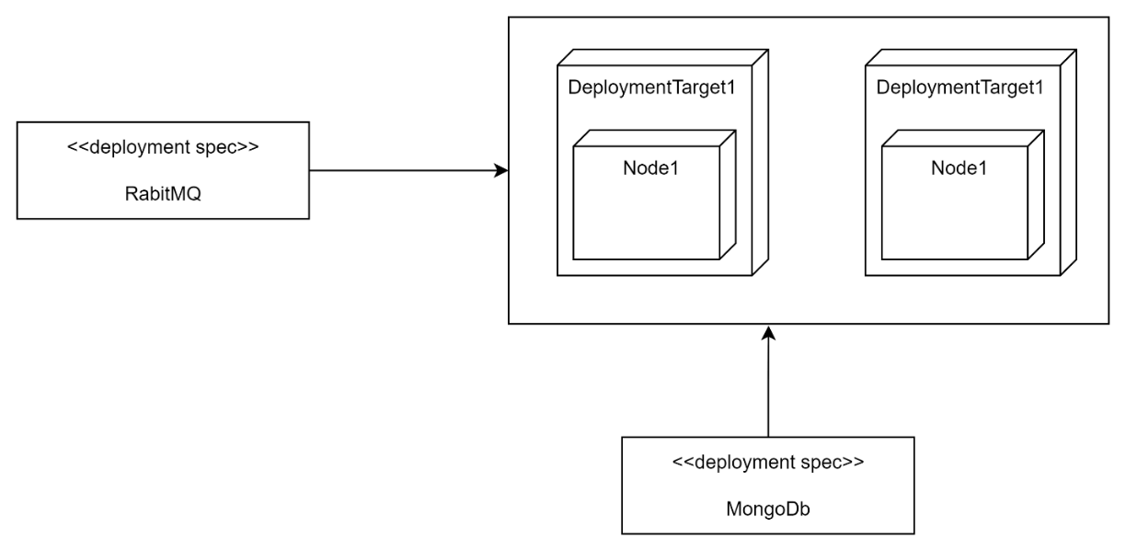

Other Interfaces
Identify any external interfaces used in the execution of this module, include technology and other pertinent data

Interface X
Message details describe in attached file

Outstanding Issues
- Outstanding Issue - Get/Query Merchant enrollment details – This is not included, since requirement and payload structure is not finalized yet

Non Functional Requirement
Non-Functional Requirement | Definition
Maintainability | Ease to change and evolve with minimal effort
Security | Encryption, password controls, storing and handling of personal and sensitive data
Testability | Ease to confirm conformance by observing a reproducible behavior
Portability | Ease to reuse for multiple platforms
Extensibility | Ease to takes into consideration future growth

References
API Reference | ISSM Merchant Enrollment | Mastercard Developers

Glossary
Acronym | Full form
NI | Network International
MQ | Message Queue
ICA | Interbank Card Association
ISSM | Identity Solutions Services Management

